**VECTR v7.0.0 Feature Breakdown**

Table of Contents

Support for Attribute Based Access Controls 2

# Support for Attribute Based Access Controls

What is it?

VECTR now supports Attribute Based Access Controls (ABAC) to granularly control access to various resources in the VECTR application.

How does it work?

From the Administration / Access Management section, you can create and manage Users:

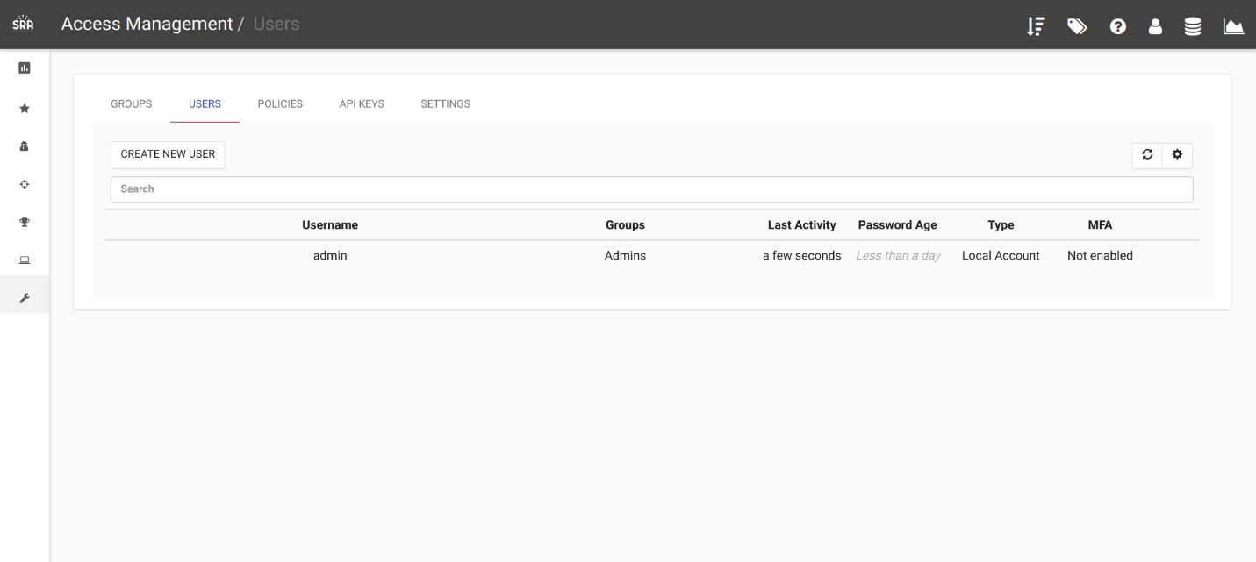

Groups:

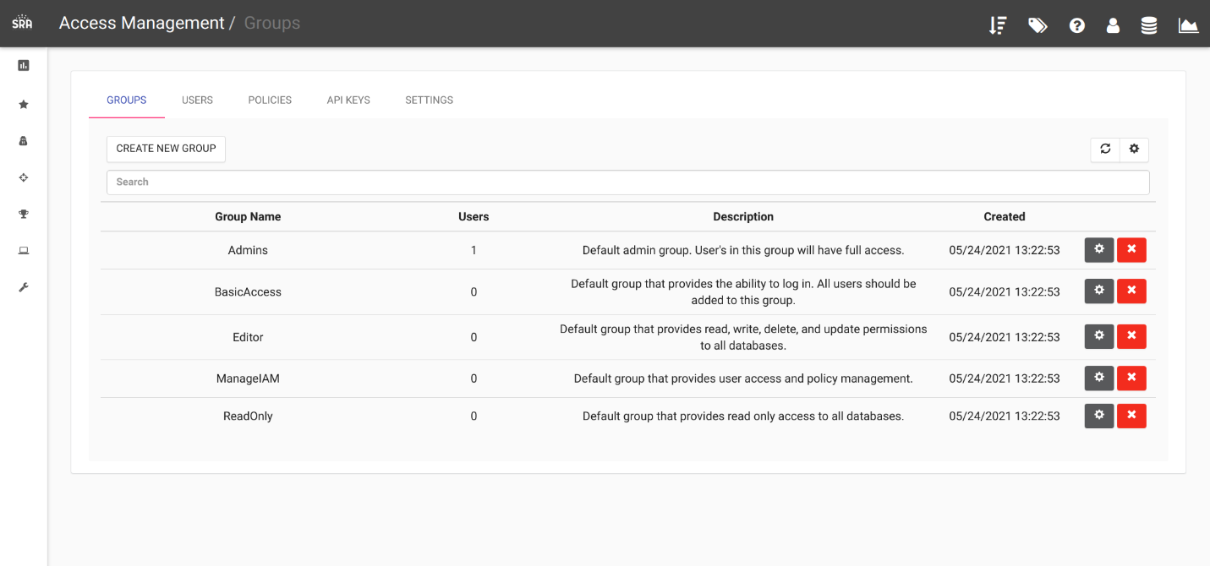

And Policies:

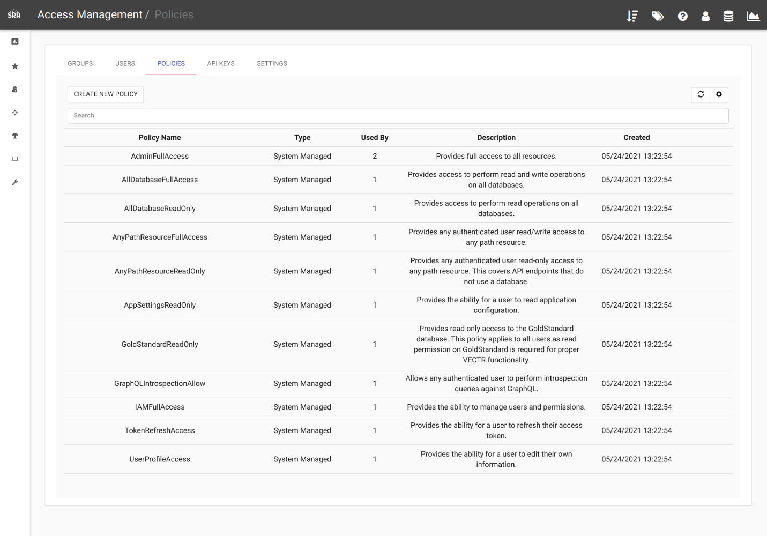

How can this feature help me?

Allows for restricting access to VECTR resources across Groups and Users.

Full documentation available on https://docs.vectr.io/iam